https://explore.skillbuilder.aws/learn/course/134/play/31418/aws-cloud-practitioner-essentials-all-modules

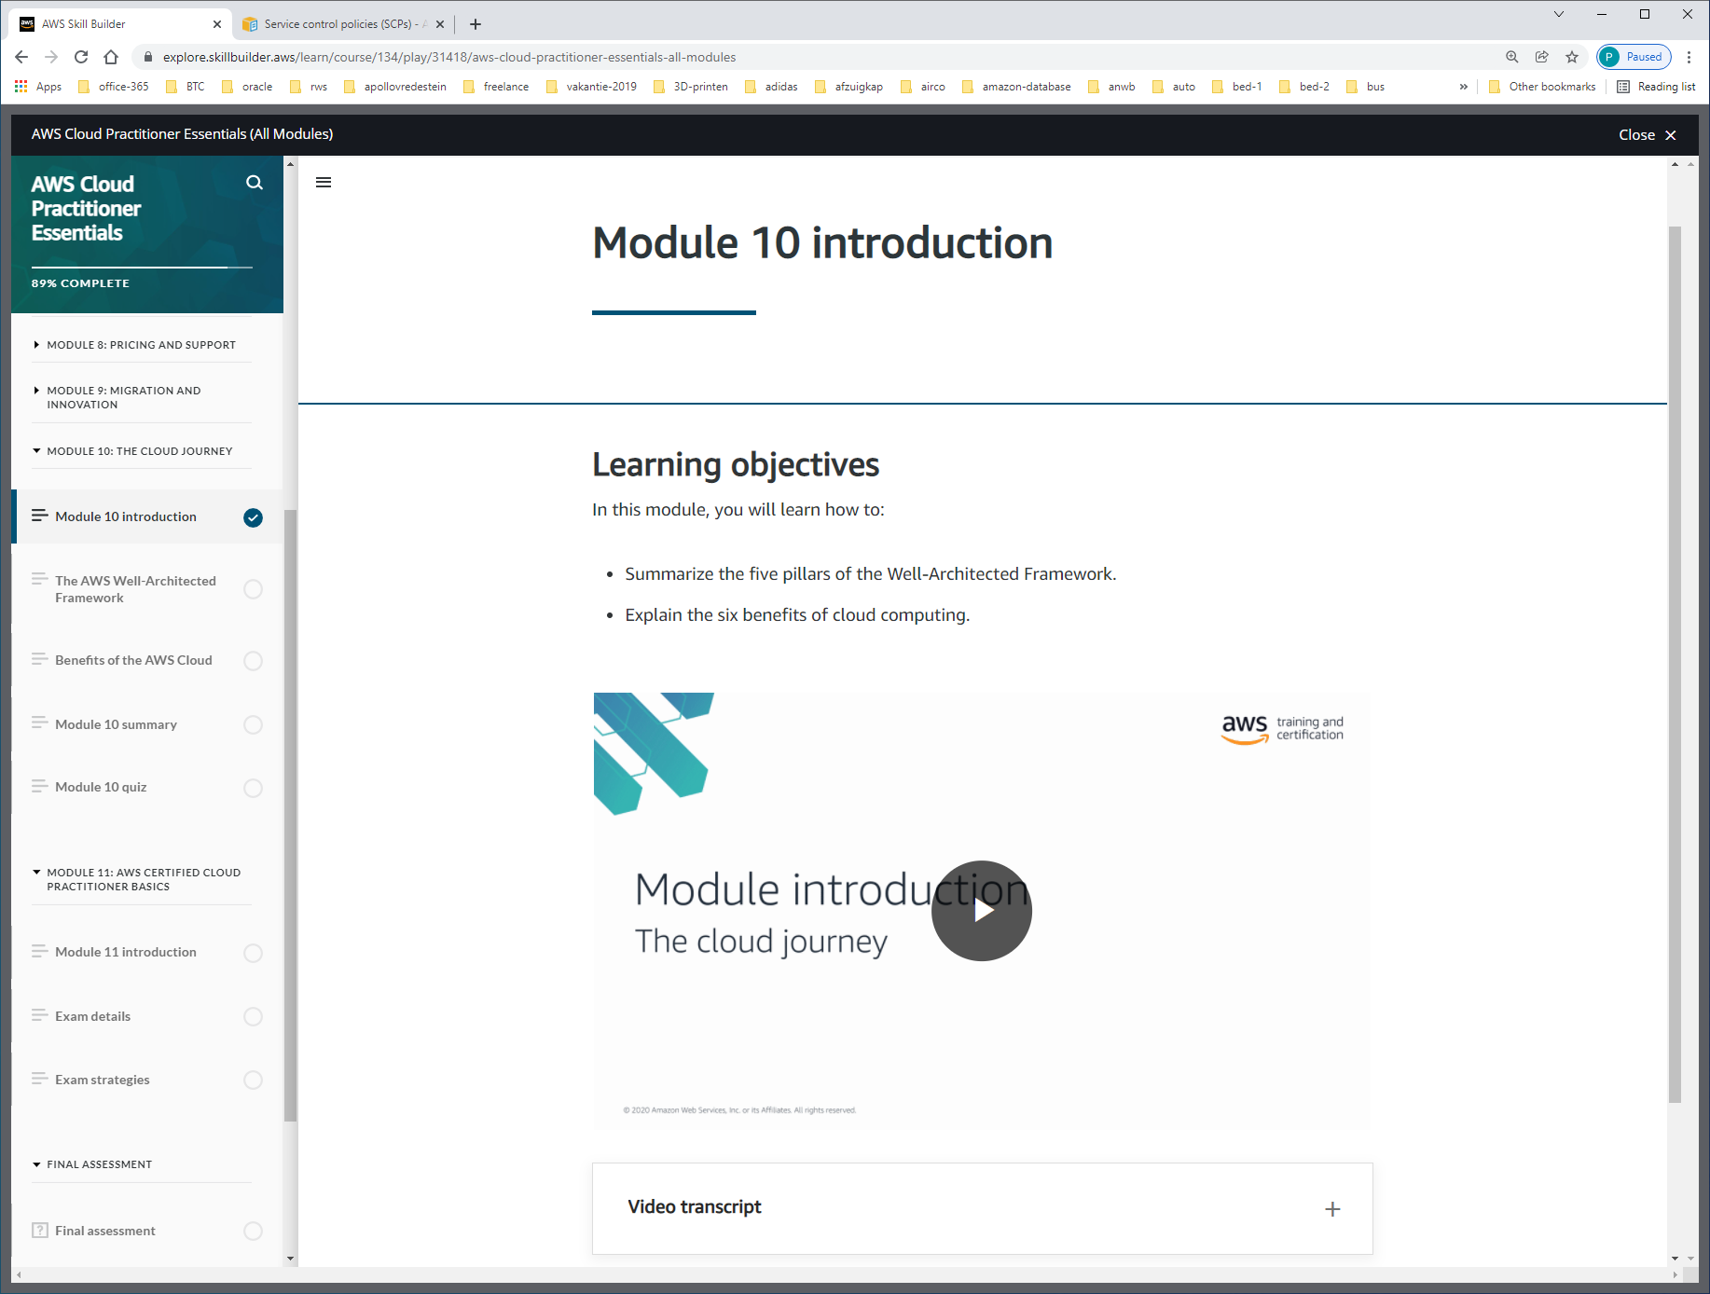

WELL ARCHITECTED ARCHITECTURE

BIJV.

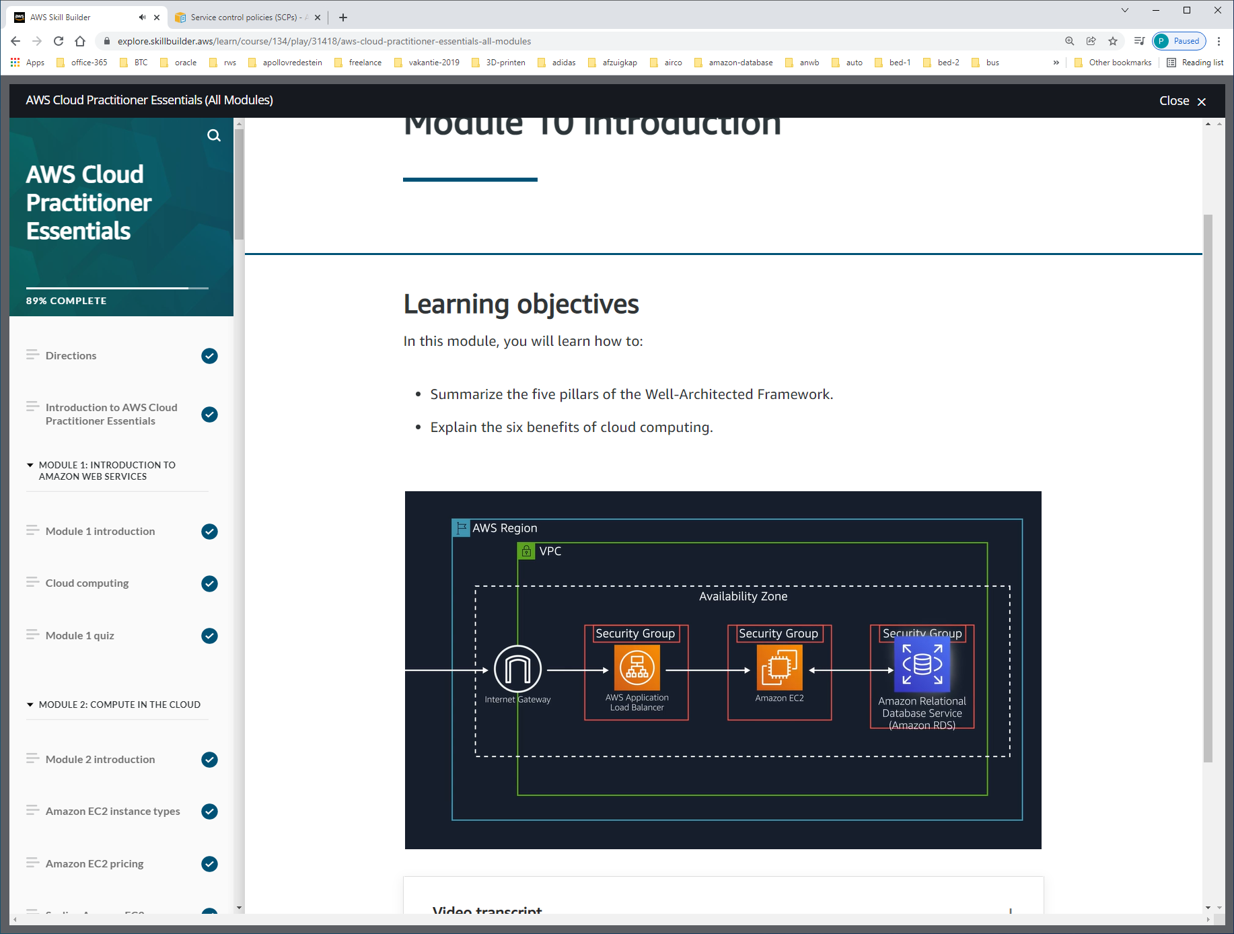

BETER VOORreliability = BESCHIKBAARHEID:

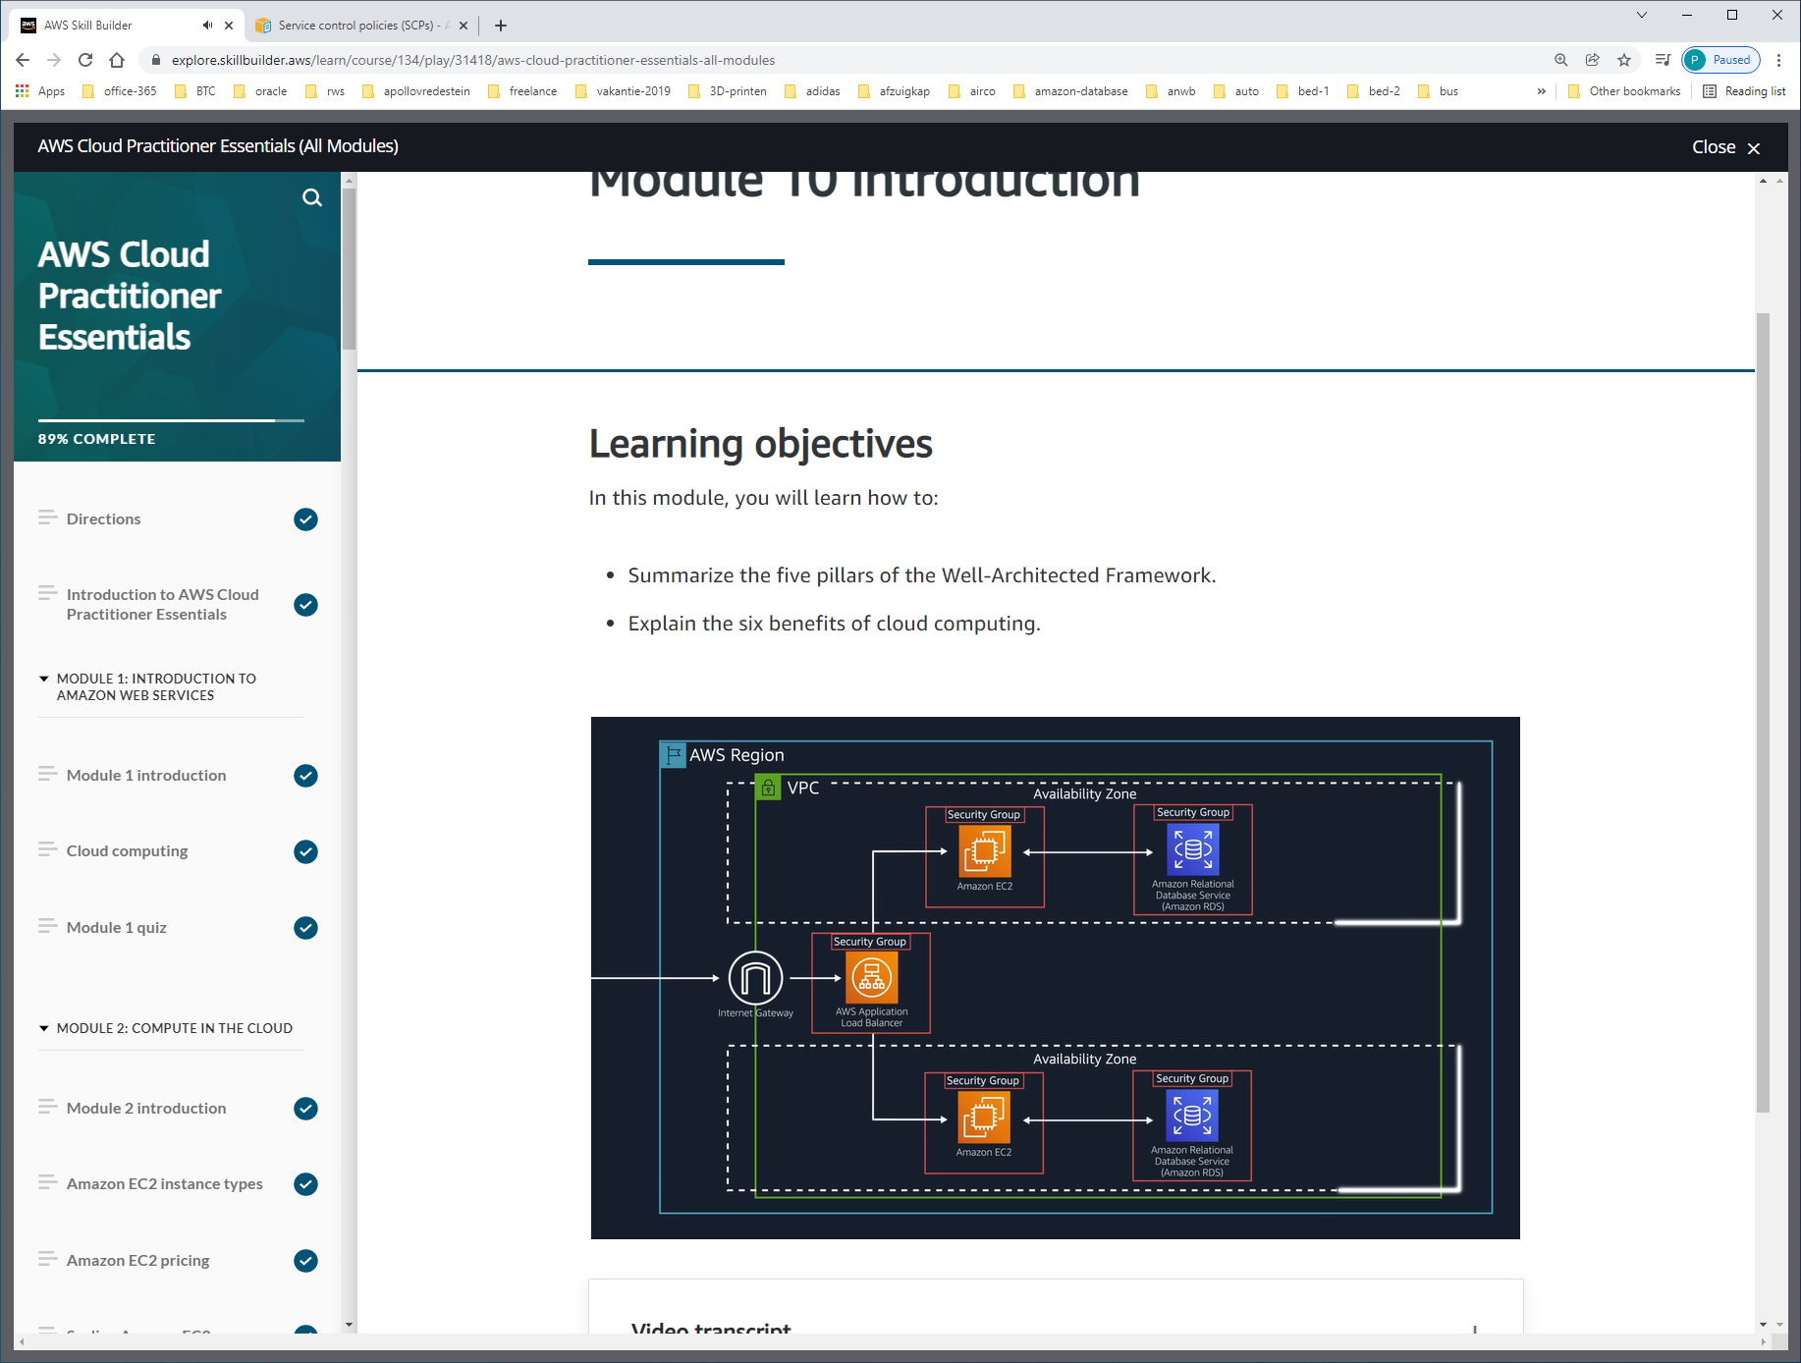

TOOL = WELL-ARCHITECTED-FRAMEWORK

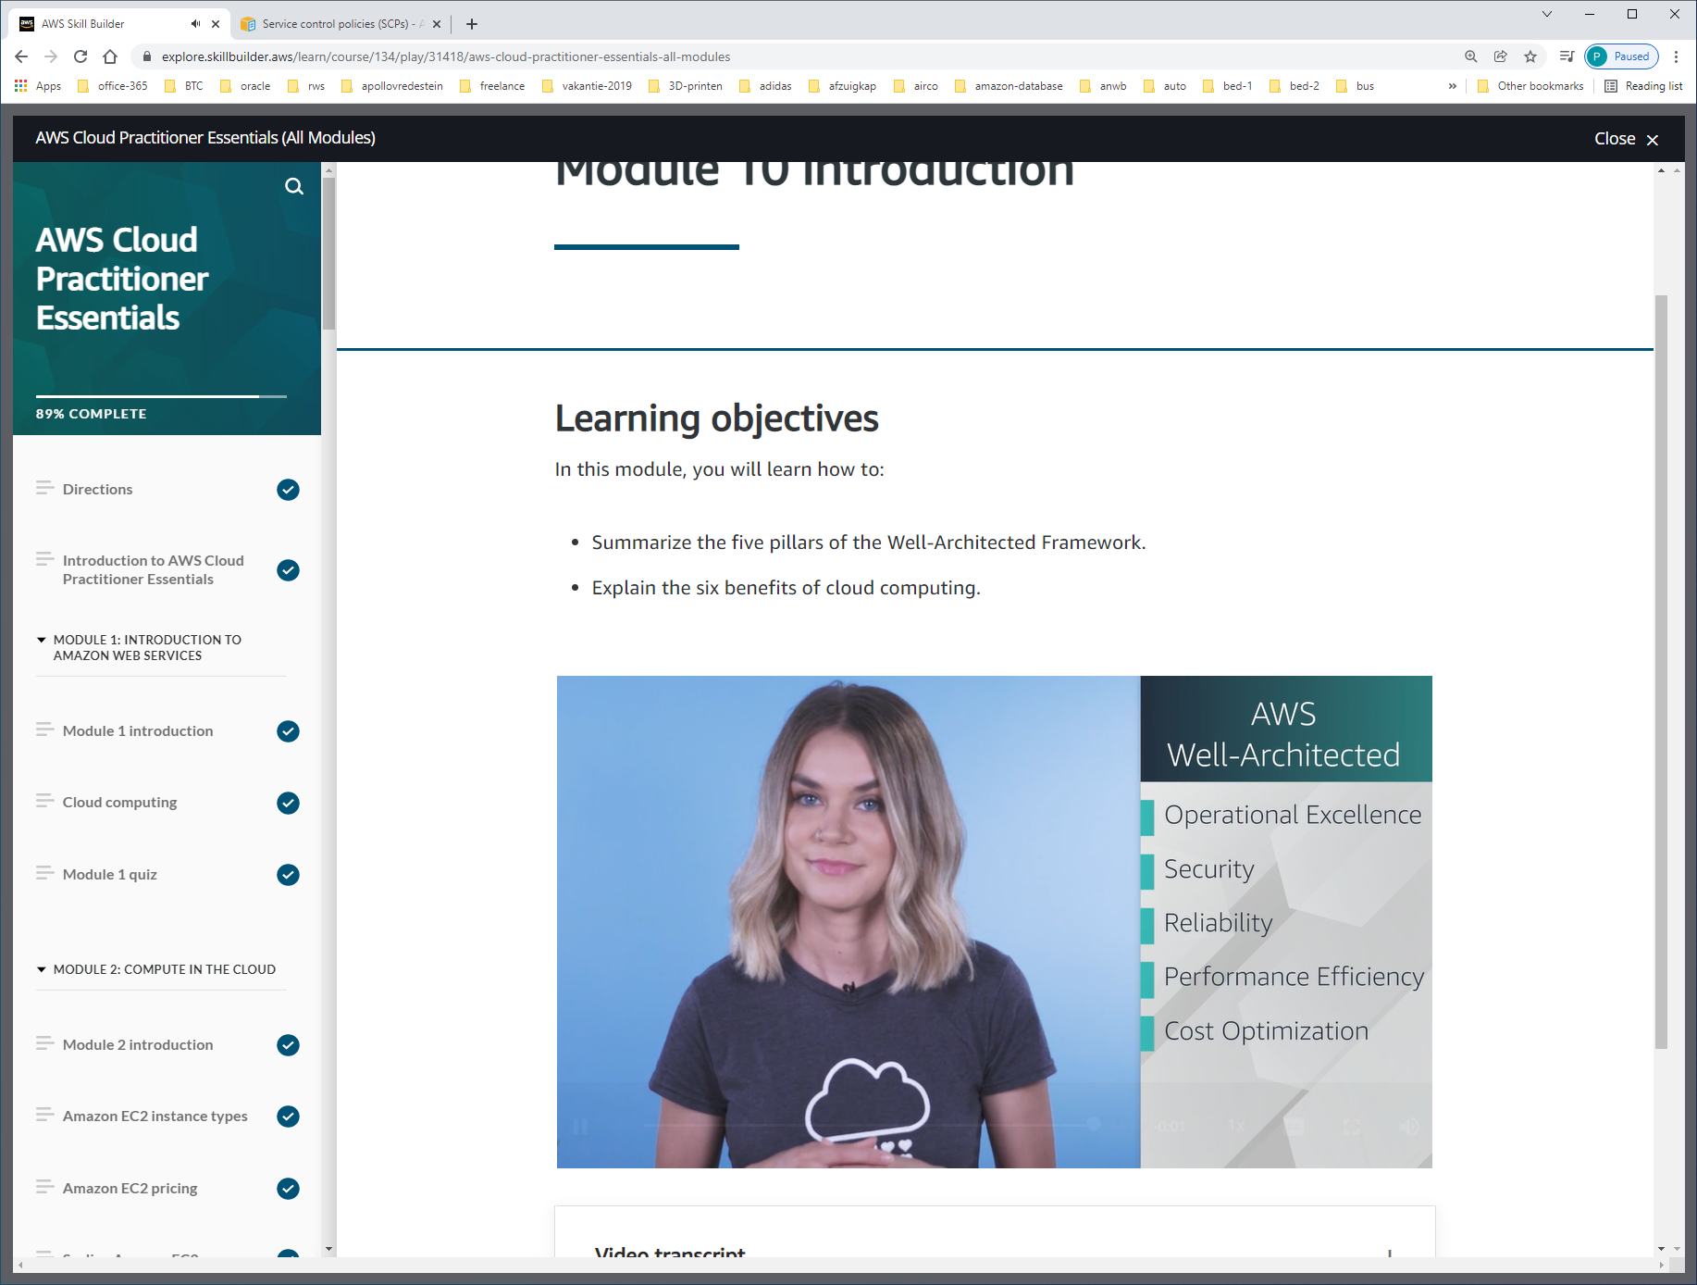

The [**AWS Well-Architected Framework**](https://d1.awsstatic.com/whitepapers/architecture/AWS_Well-Architected_Framework.pdf) helps you understand how to design and operate reliable, secure, efficient, and cost-effective systems in the AWS Cloud. It provides a way for you to consistently measure your architecture against best practices and design principles and identify areas for improvement.

The Well-Architected Framework is based on five pillars:

* Operational excellence
* Security
* Reliability
* Performance efficiency
* Cost optimization

**Operational excellence** is the ability to run and monitor systems to deliver business value and to continually improve supporting processes and procedures.

Design principles for operational excellence in the cloud include performing operations as code, annotating documentation, anticipating failure, and frequently making small, reversible changes.

The **Security** pillar is the ability to protect information, systems, and assets while delivering business value through risk assessments and mitigation strategies.

When considering the security of your architecture, apply these best practices:

* Automate security best practices when possible.
* Apply security at all layers.
* Protect data in transit and at rest.

**Reliability** is the ability of a system to do the following:

* Recover from infrastructure or service disruptions
* Dynamically acquire computing resources to meet demand
* Mitigate disruptions such as misconfigurations or transient network issues

Reliability includes testing recovery procedures, scaling horizontally to increase aggregate system availability, and automatically recovering from failure.

**Performance efficiency** is the ability to use computing resources efficiently to meet system requirements and to maintain that efficiency as demand changes and technologies evolve.

Evaluating the performance efficiency of your architecture includes experimenting more often, using serverless architectures, and designing systems to be able to go global in minutes.

**Cost optimization** is the ability to run systems to deliver business value at the lowest price point.

Cost optimization includes adopting a consumption model, analyzing and attributing expenditure, and using managed services to reduce the cost of ownership

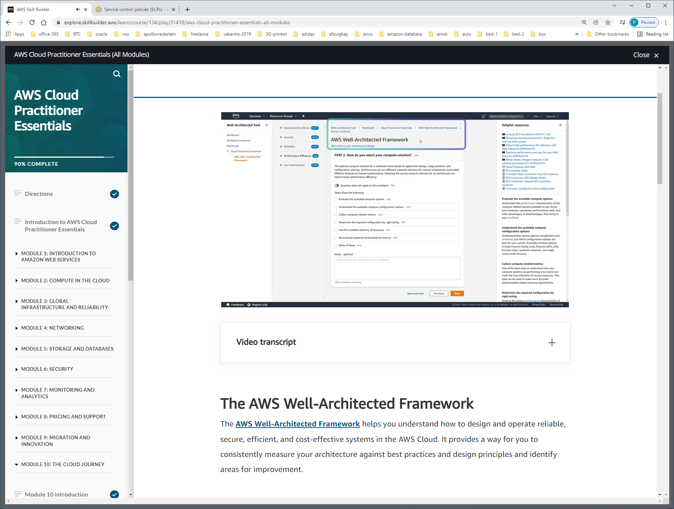

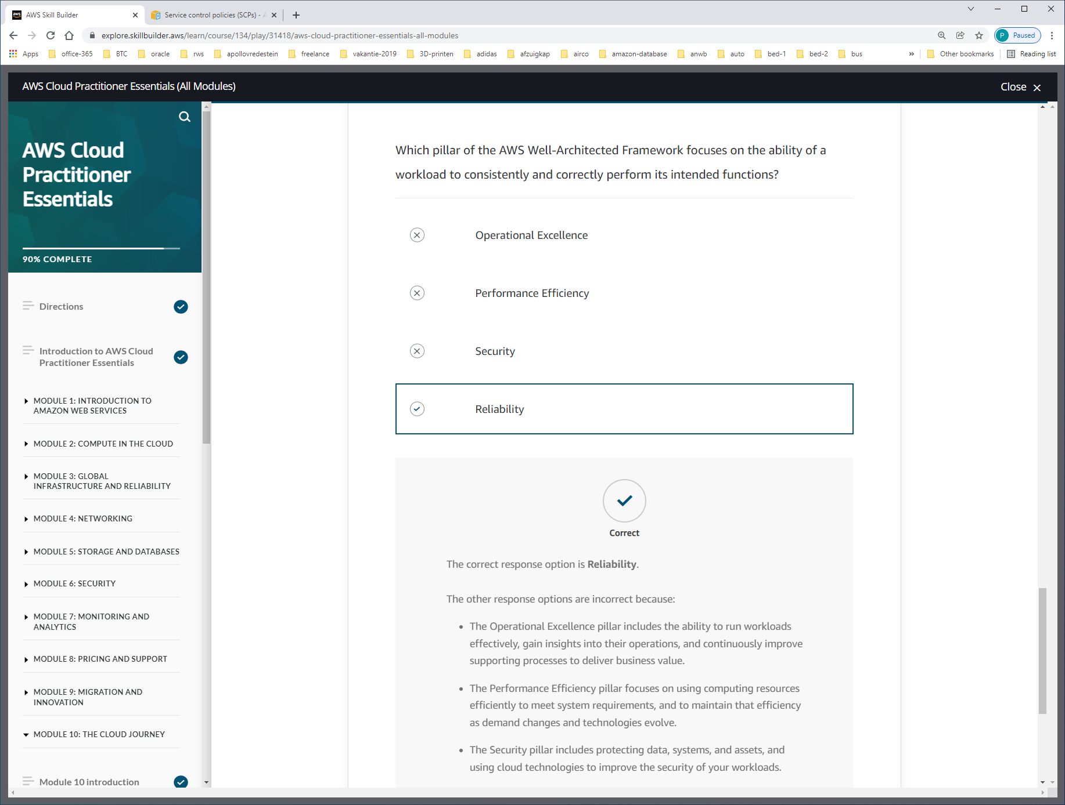

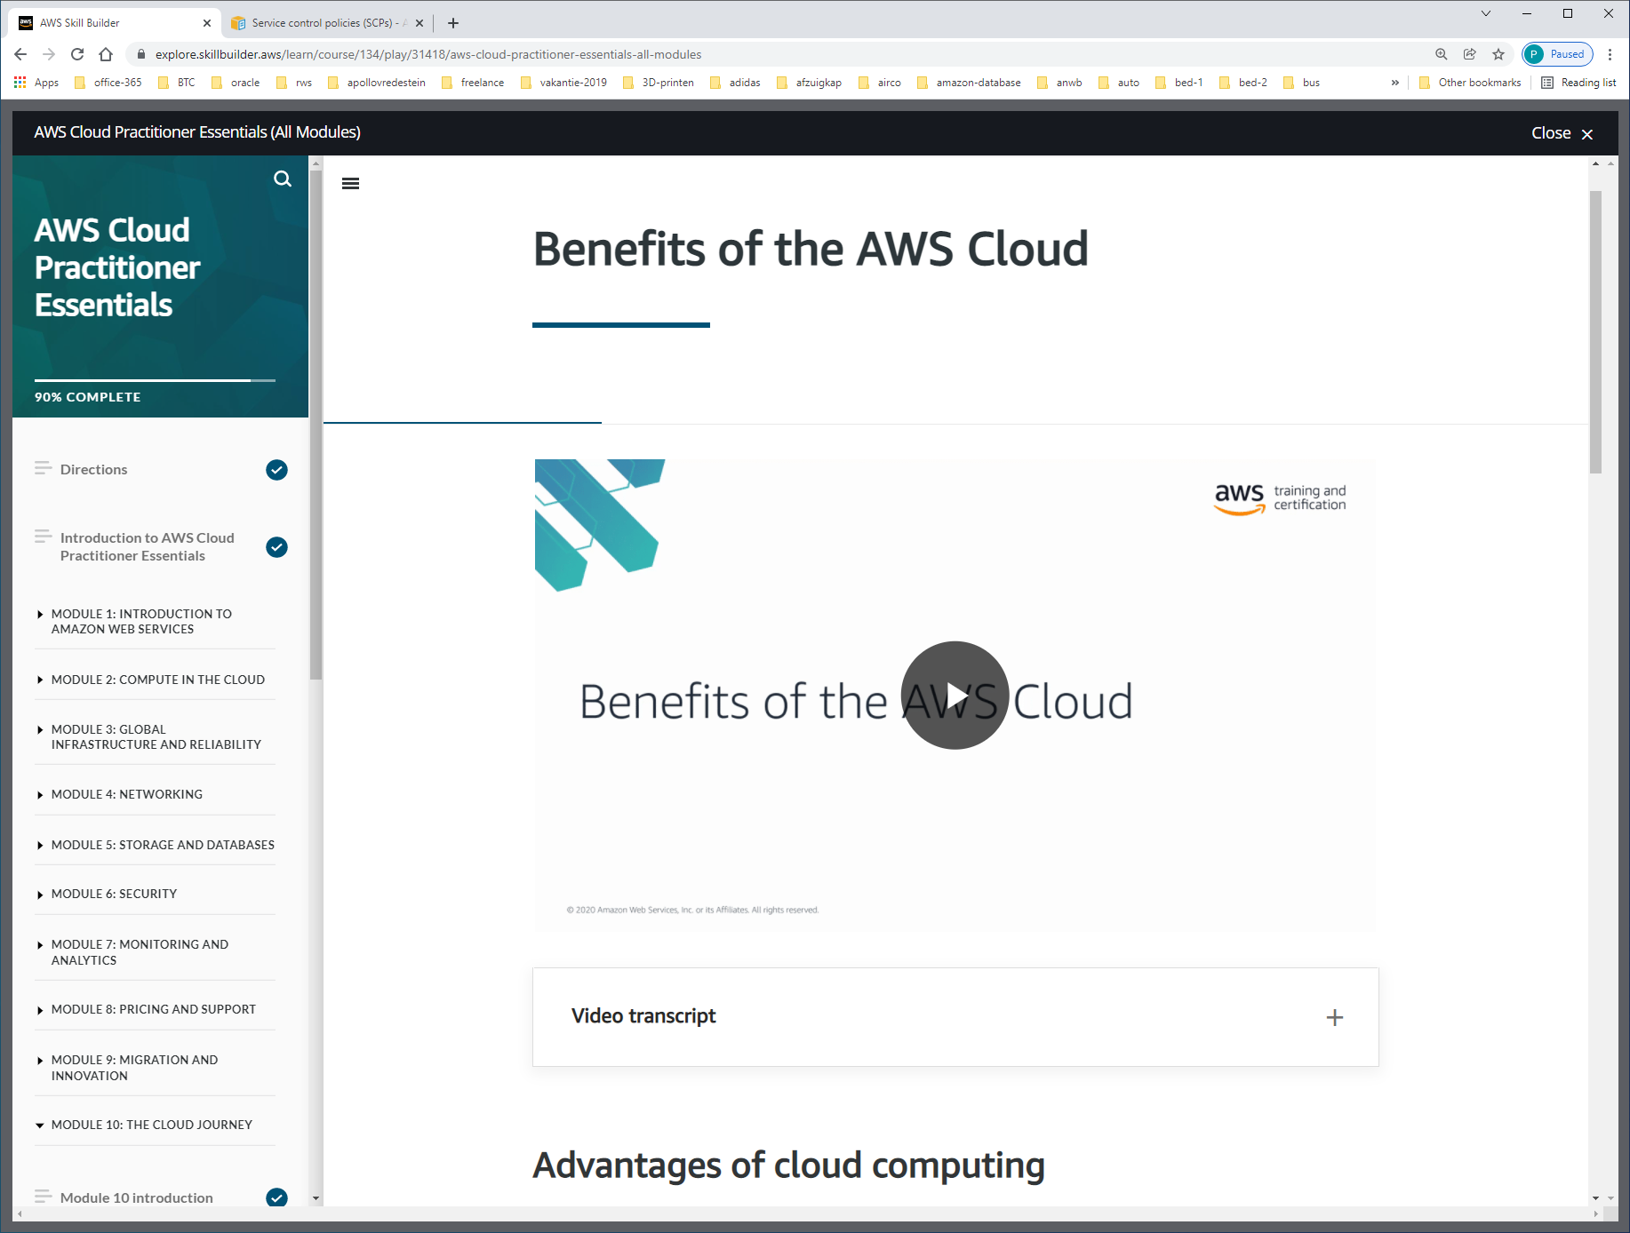

Operating in the AWS Cloud offers many benefits over computing in on-premises or hybrid environments.

In this section, you will learn about six advantages of cloud computing:

* Trade upfront expense for variable expense.
* Benefit from massive economies of scale.
* Stop guessing capacity.
* Increase speed and agility.
* Stop spending money running and maintaining data centers.
* Go global in minutes.

**Trade upfront expense for variable expense.**

Upfront expenses include data centers, physical servers, and other resources that you would need to invest in before using computing resources.

Instead of investing heavily in data centers and servers before you know how you’re going to use them, you can pay only when you consume computing resources.

**Benefit from massive economies of scale.**

By using cloud computing, you can achieve a lower variable cost than you can get on your own.

Because usage from hundreds of thousands of customers aggregates in the cloud, providers such as AWS can achieve higher economies of scale. Economies of scale translate into lower pay-as-you-go prices.

**Stop guessing capacity.**

With cloud computing, you don’t have to predict how much infrastructure capacity you will need before deploying an application.

For example, you can launch Amazon Elastic Compute Cloud (Amazon EC2) instances when needed and pay only for the compute time you use. Instead of paying for resources that are unused or dealing with limited capacity, you can access only the capacity that you need, and scale in or out in response to demand.

**Increase speed and agility.**

The flexibility of cloud computing makes it easier for you to develop and deploy applications.

This flexibility also provides your development teams with more time to experiment and innovate.

**Stop spending money running and maintaining data centers.**

Cloud computing in data centers often requires you to spend more money and time managing infrastructure and servers.

A benefit of cloud computing is the ability to focus less on these tasks and more on your applications and customers.

**Go global in minutes.**

The AWS Cloud global footprint enables you to quickly deploy applications to customers around the world, while providing them with low latency.

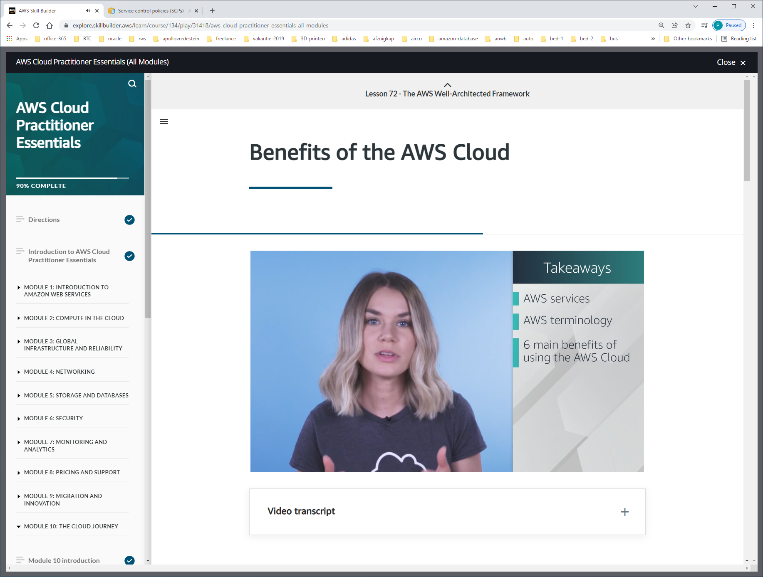

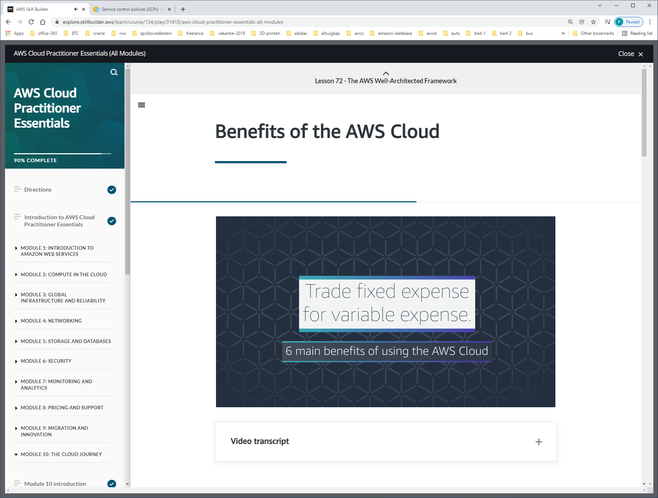

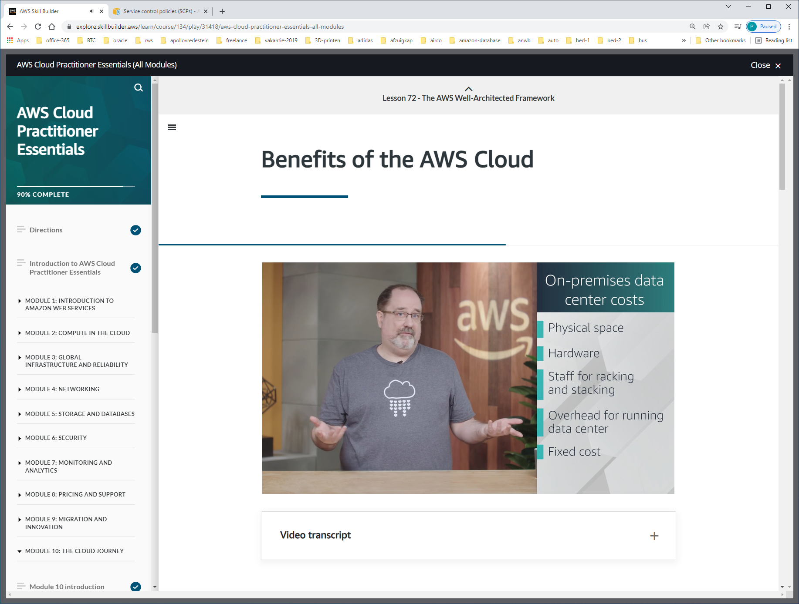

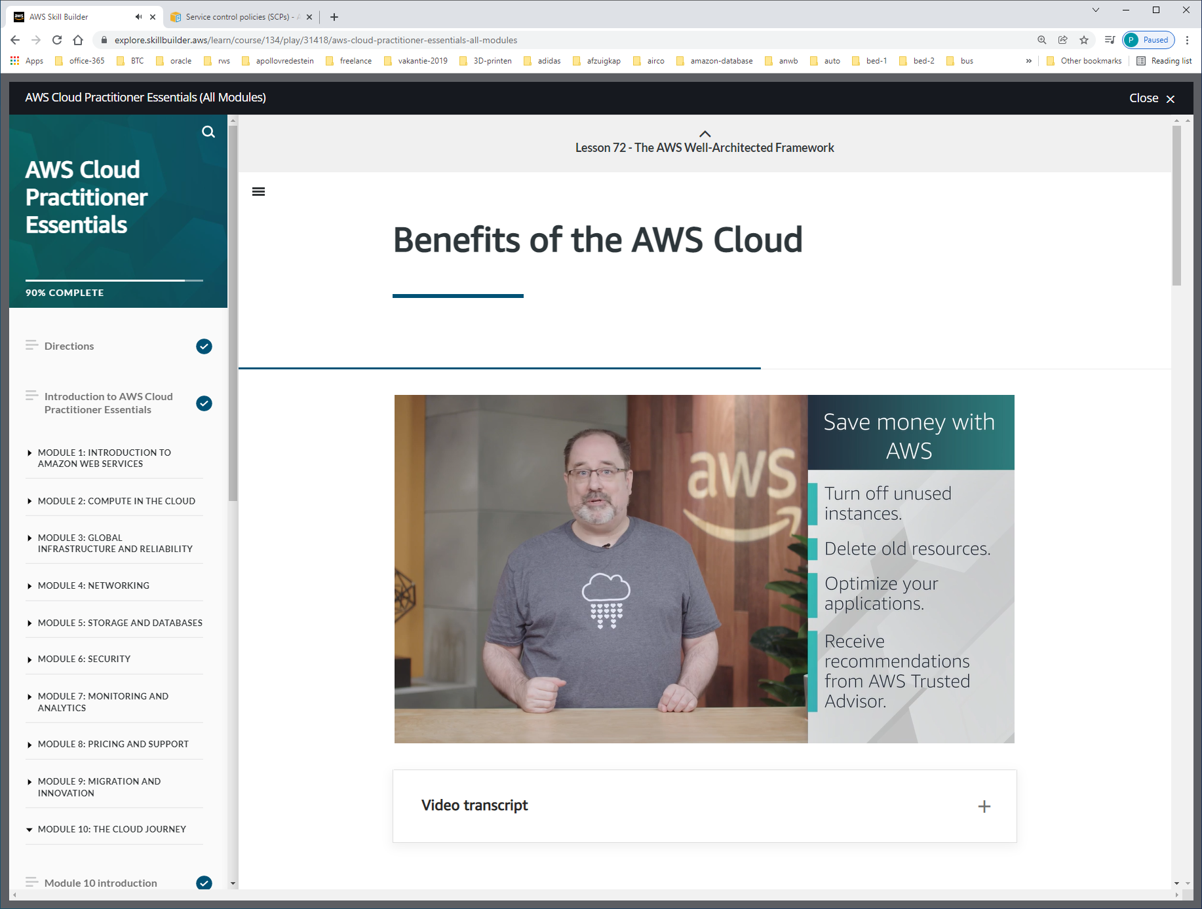

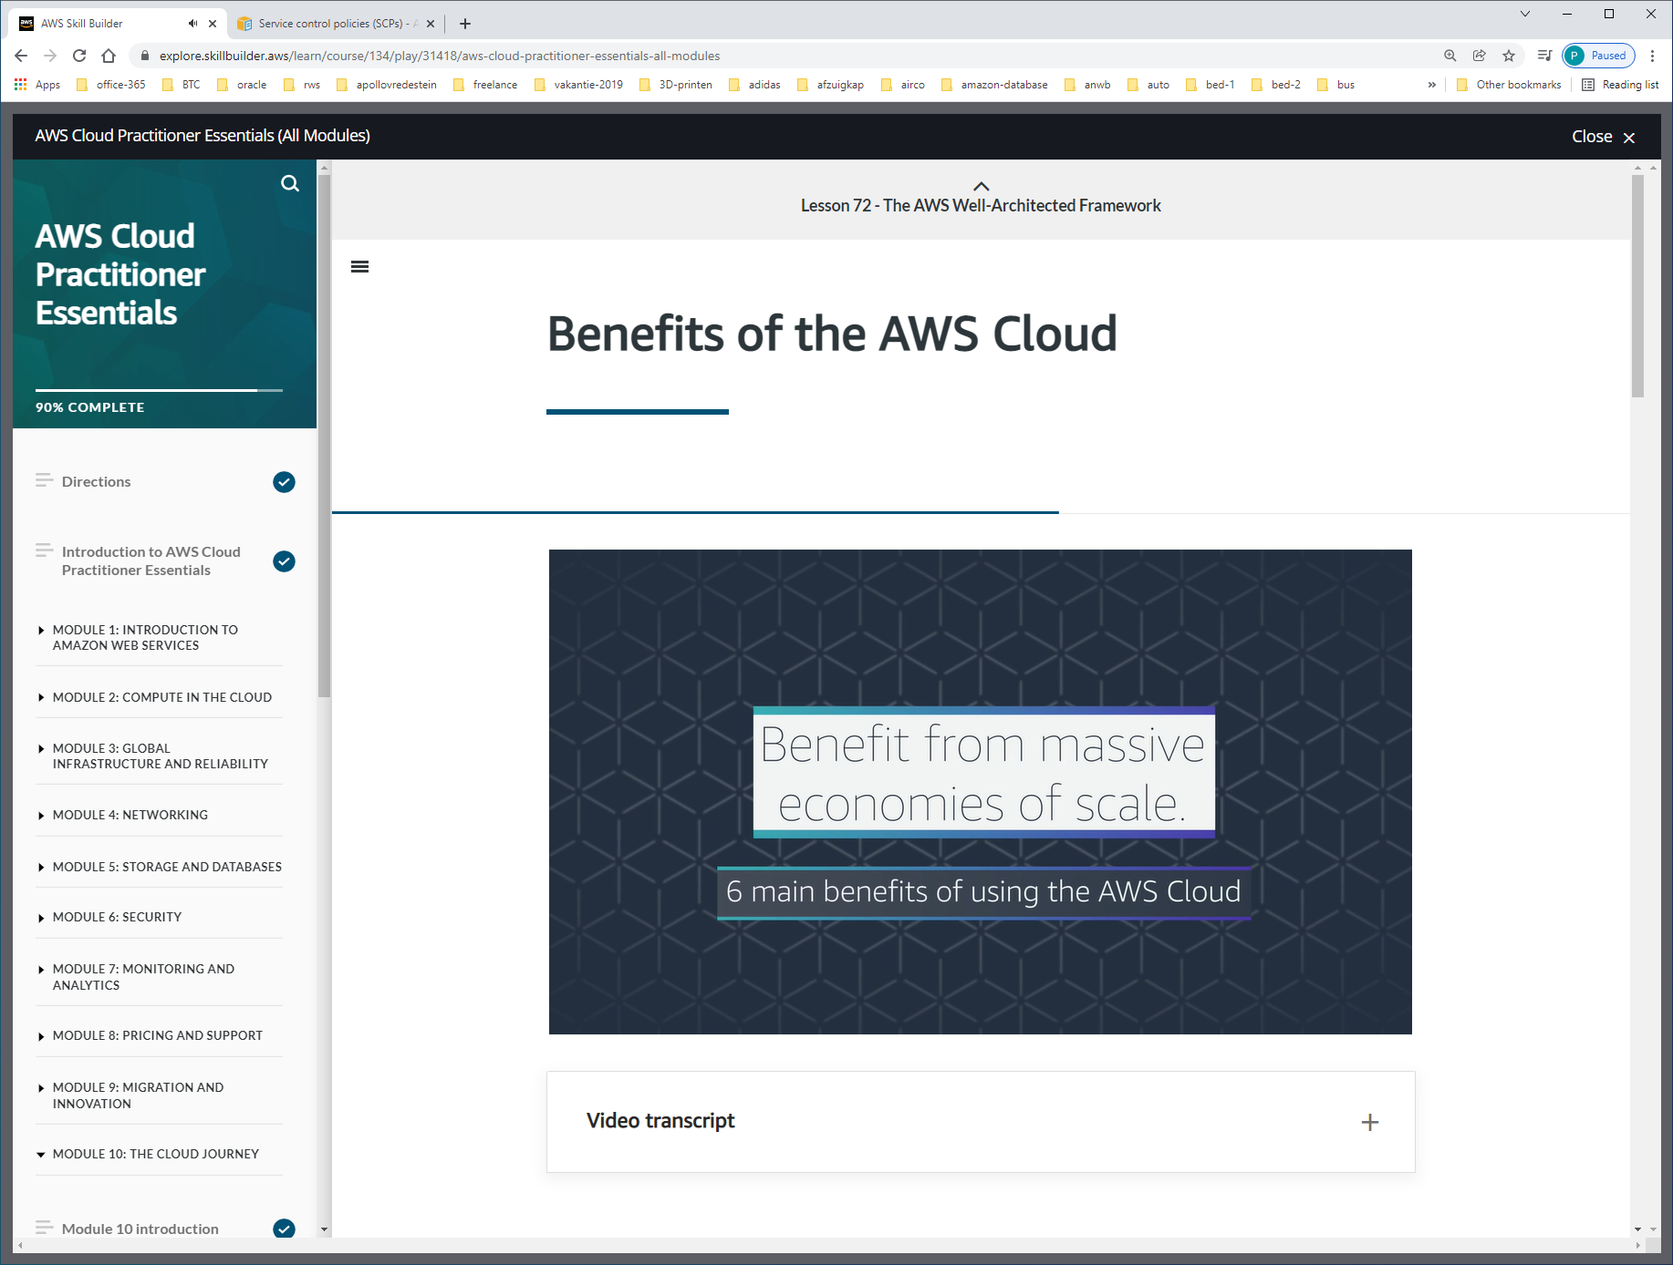

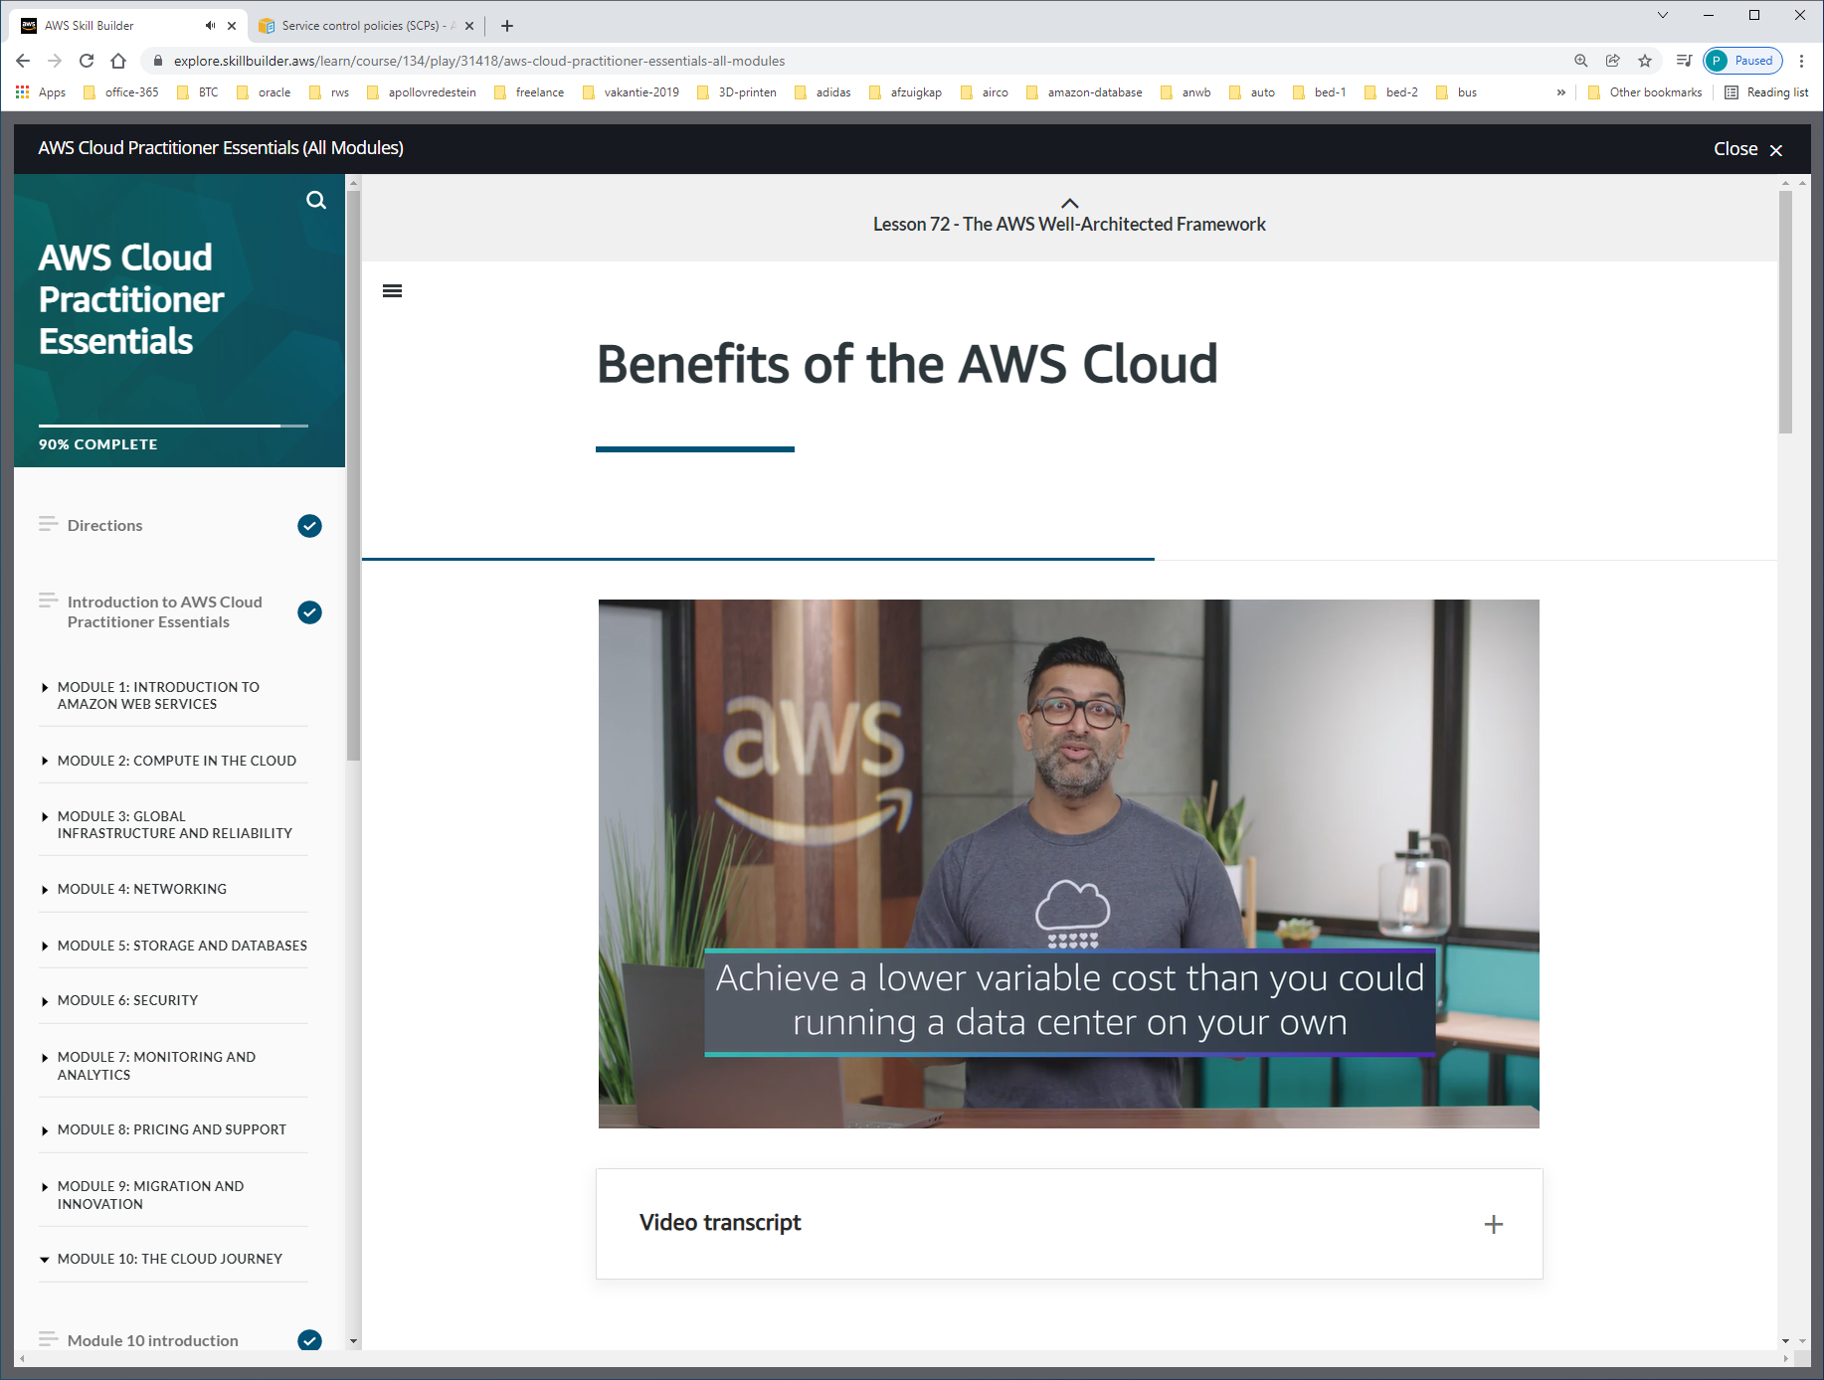

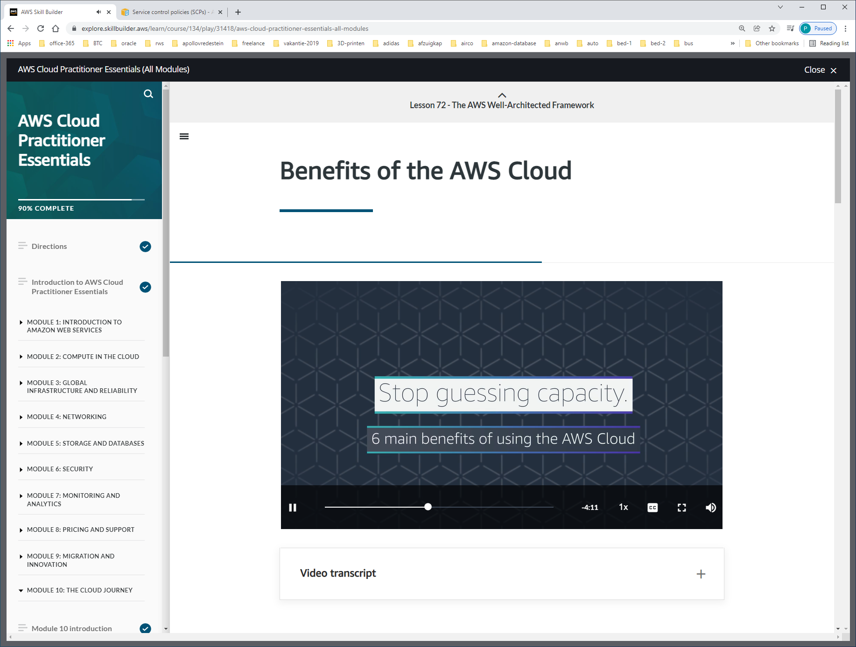

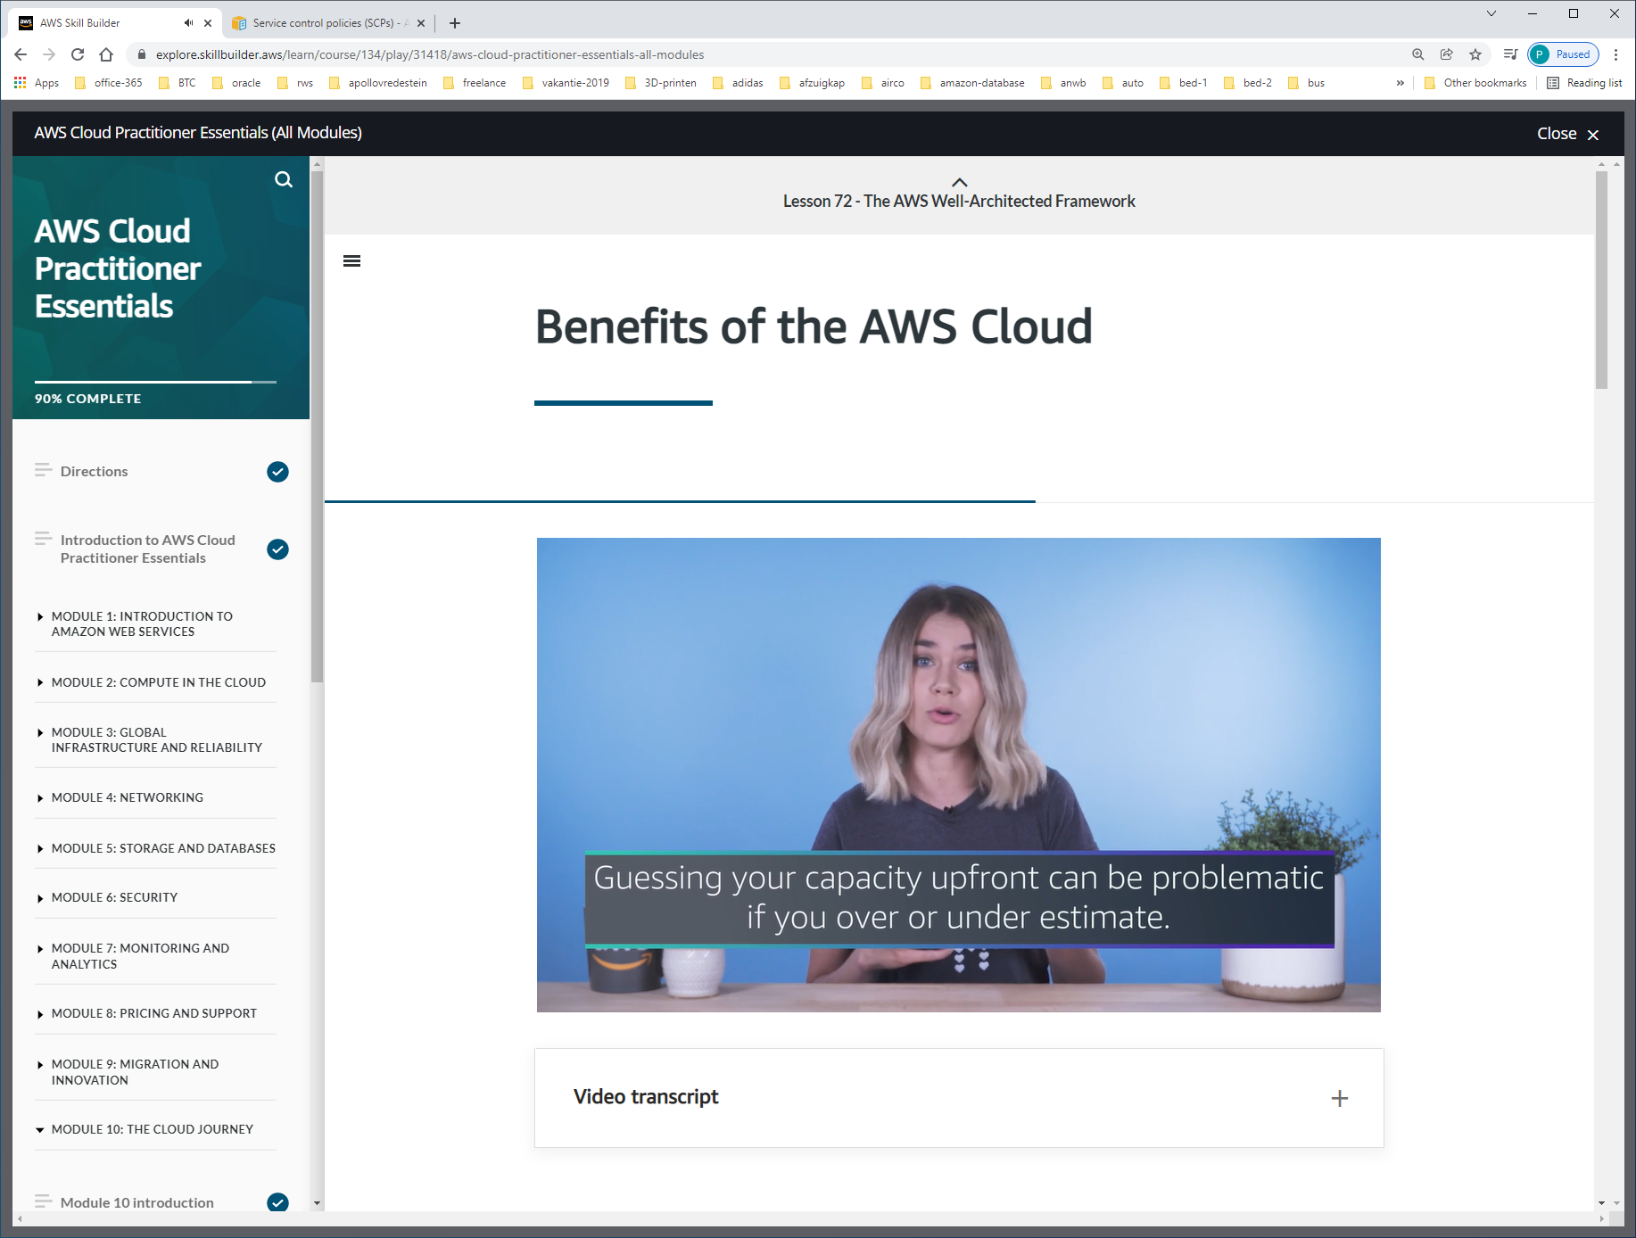

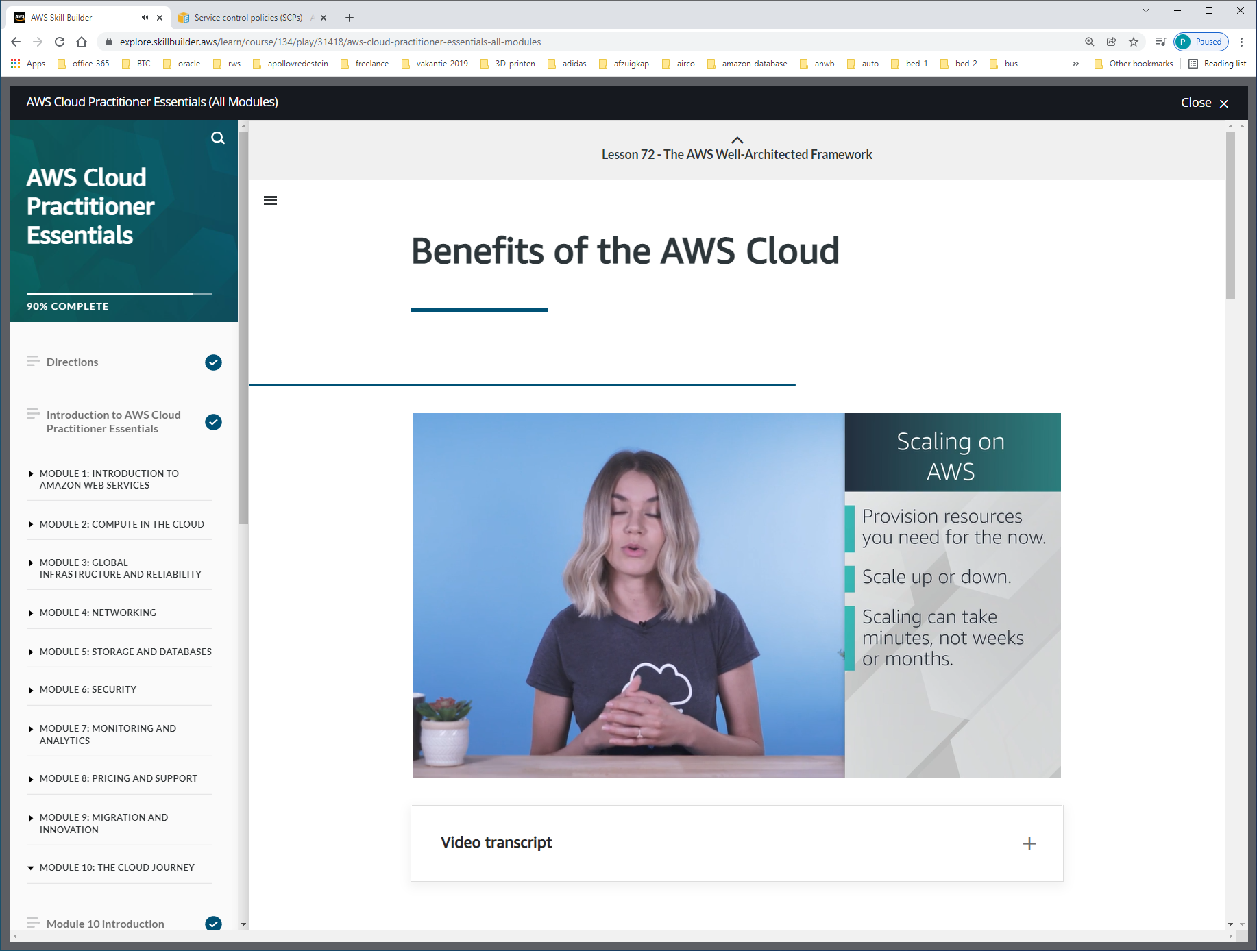

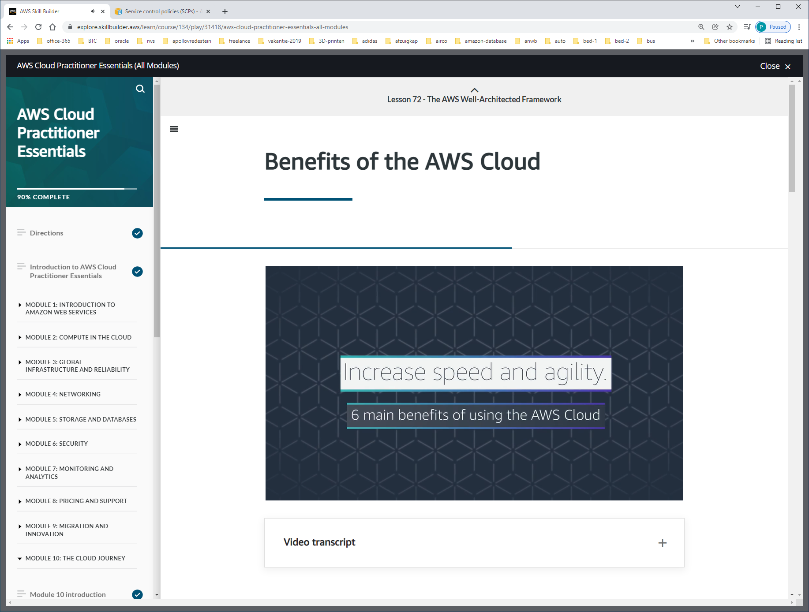

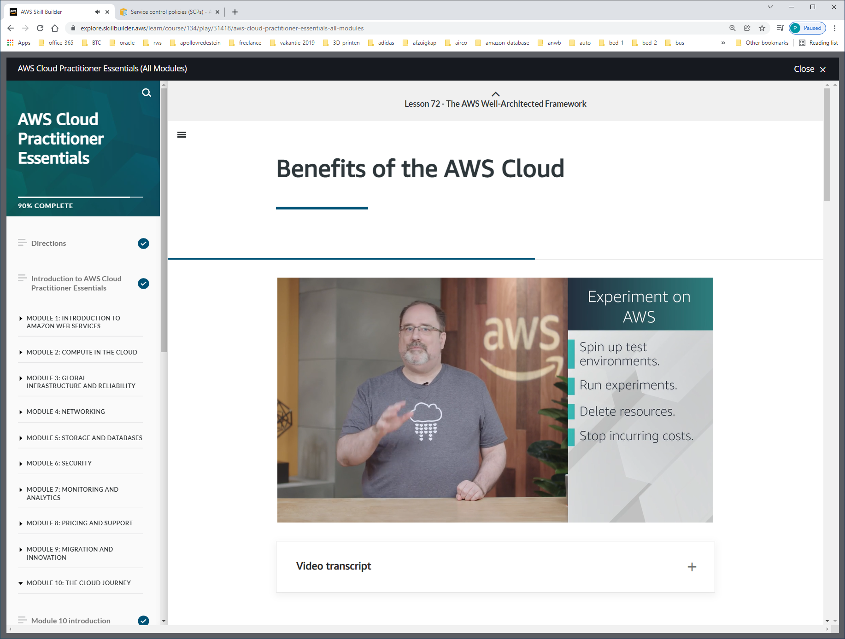

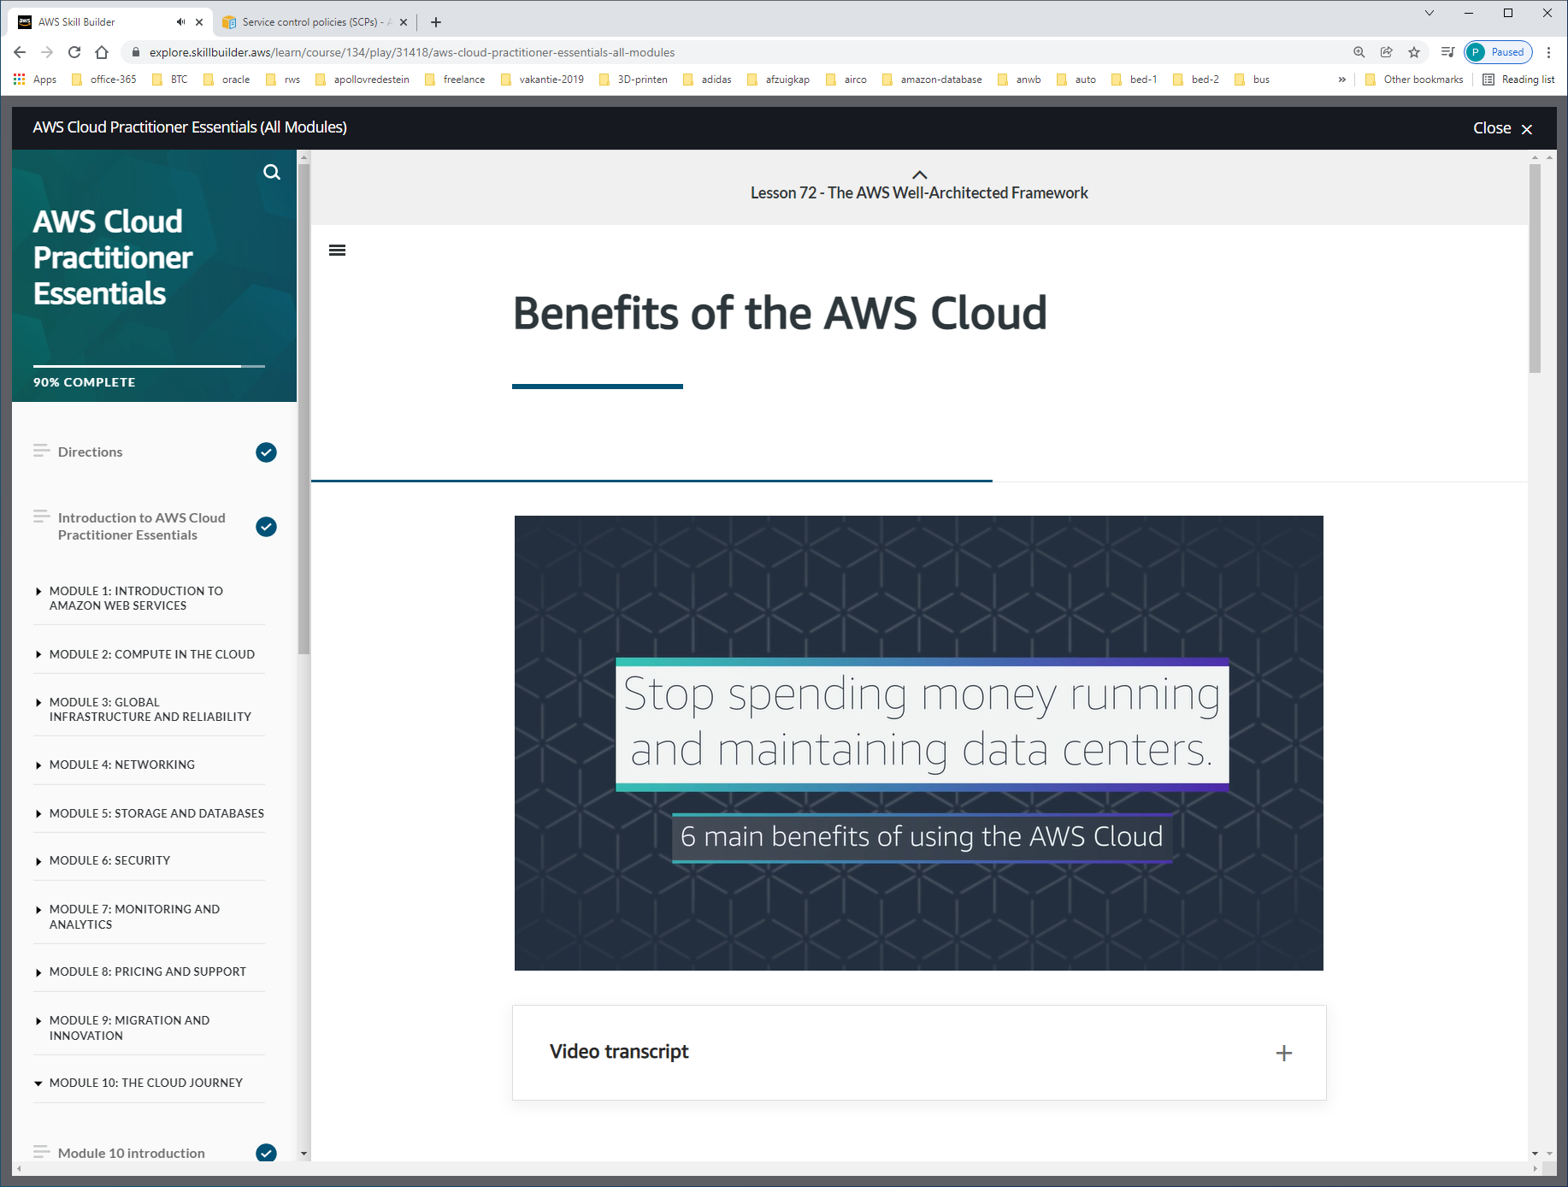

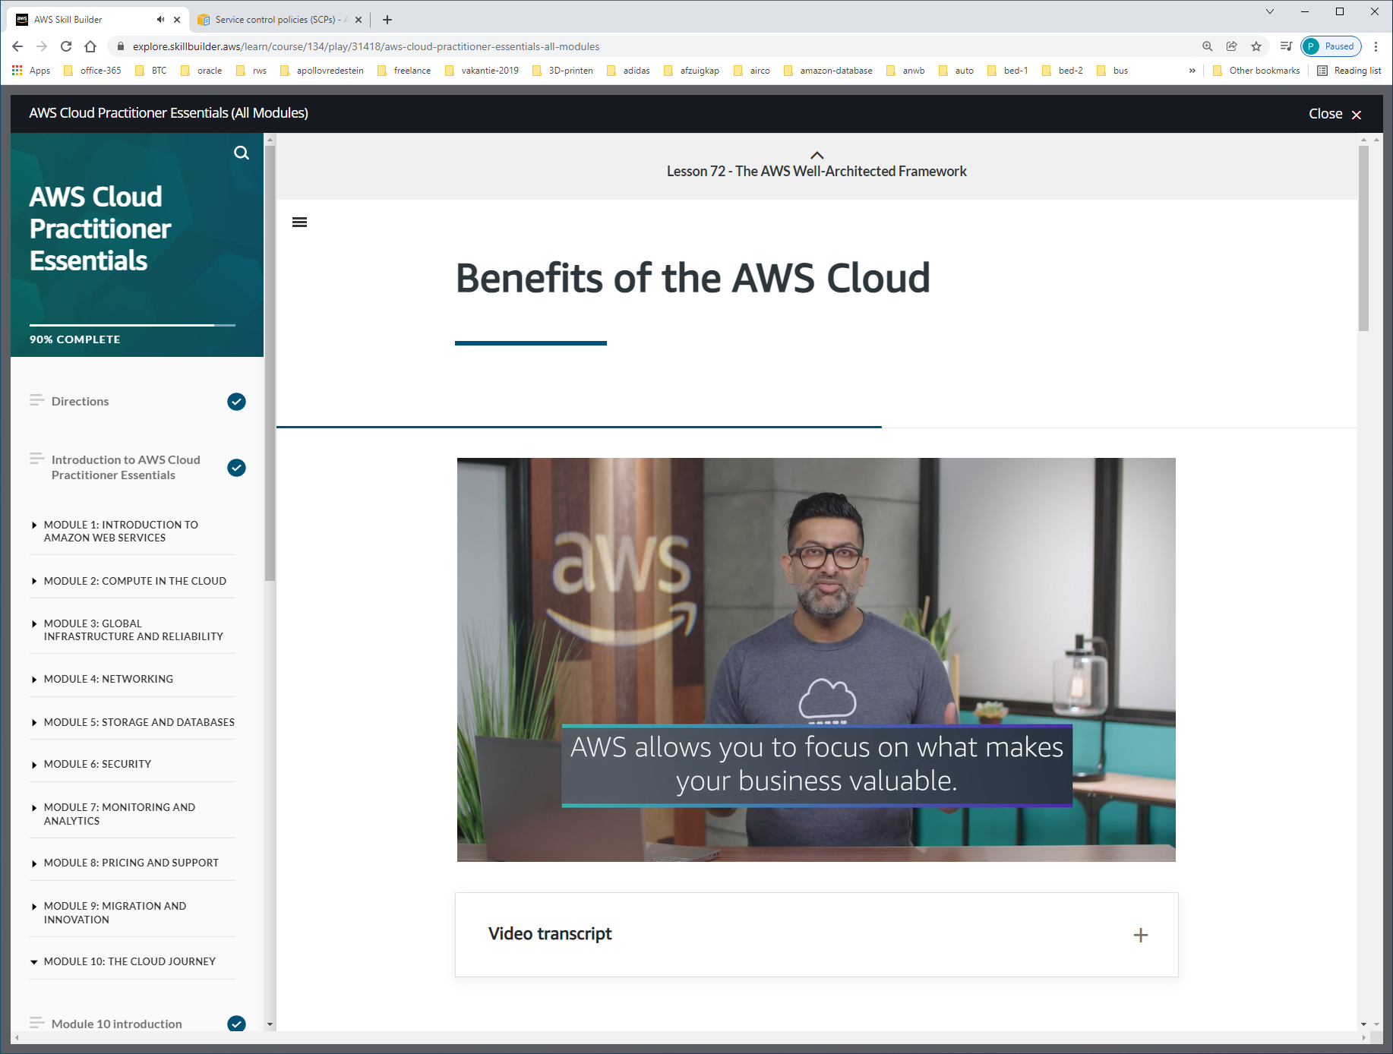

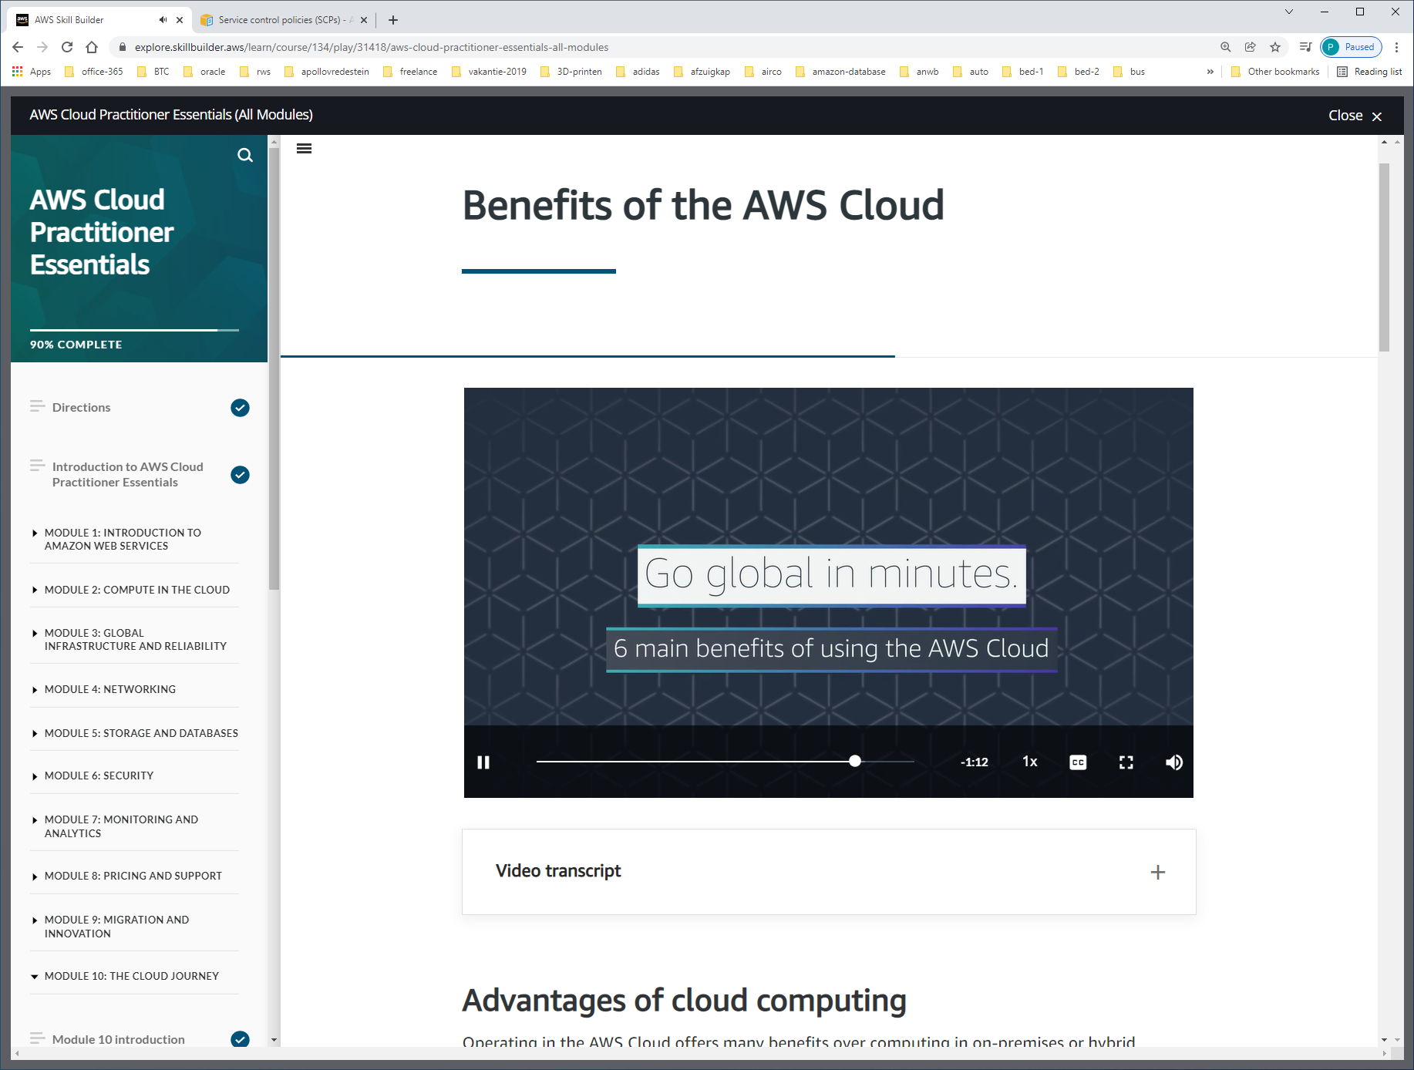

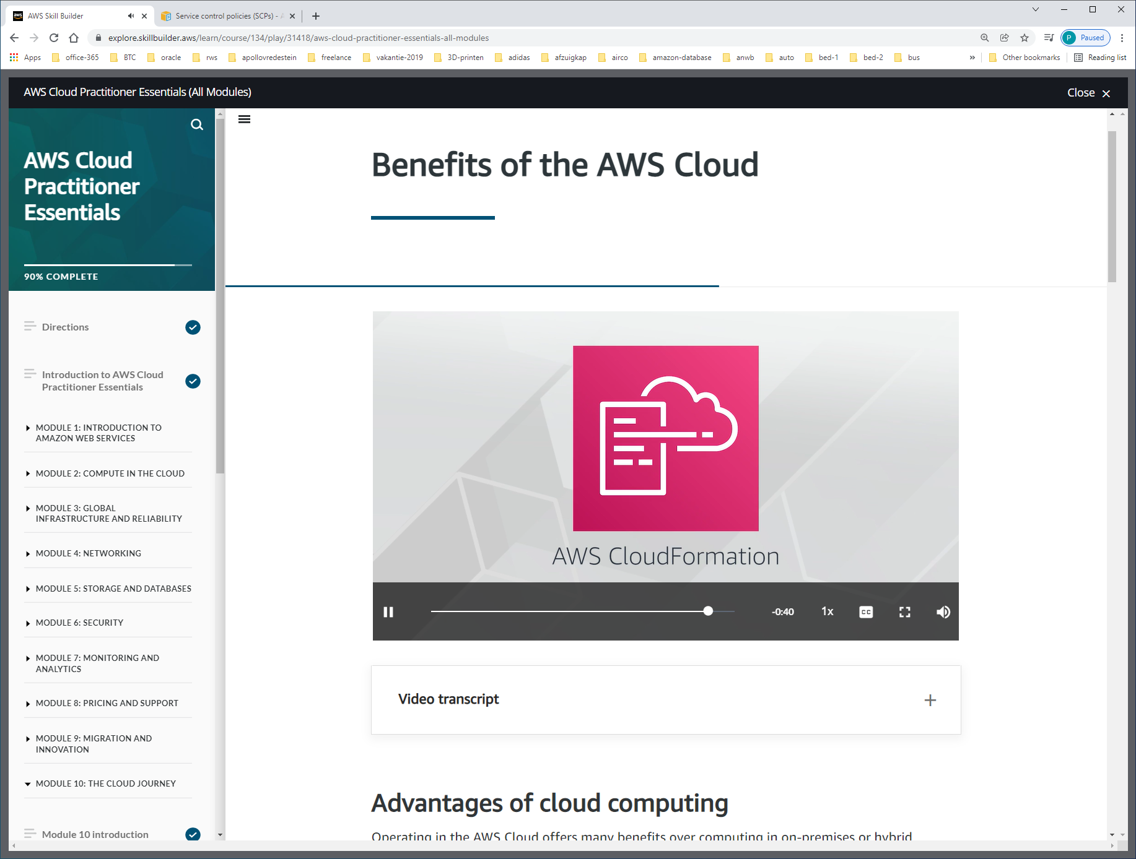

Met AWS-cloudformation kun je via tool/gautomatiseerd een replicated-environment creeren in een andere REGION.

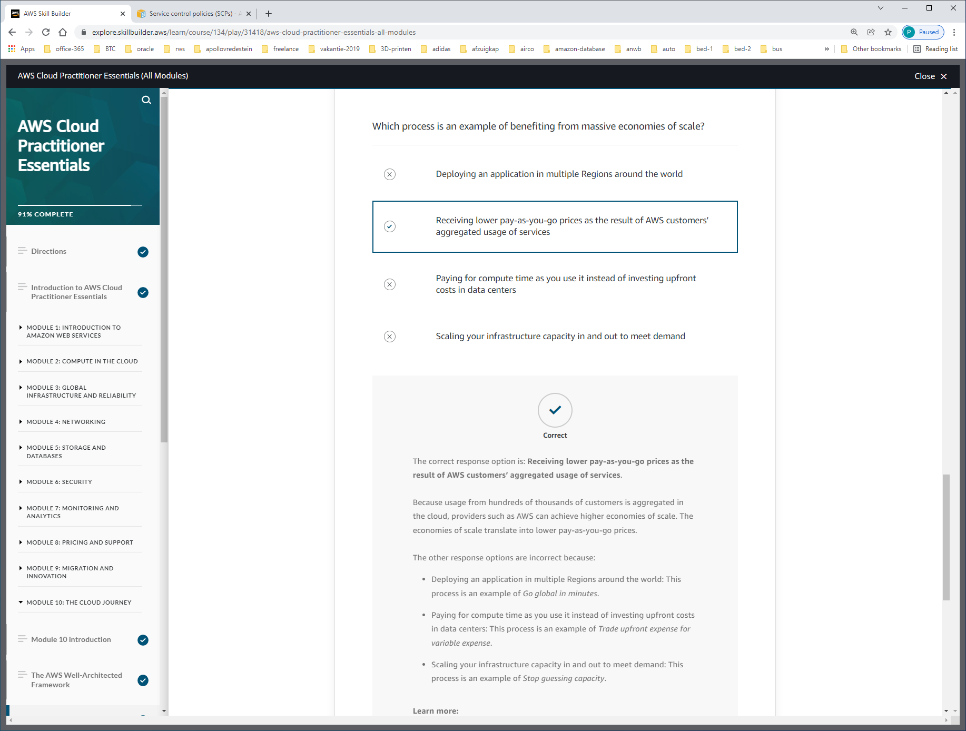

The correct response option is: **Receiving lower pay-as-you-go prices as the result of AWS customers’ aggregated usage of services**.

Because usage from hundreds of thousands of customers is aggregated in the cloud, providers such as AWS can achieve higher economies of scale. The economies of scale translate into lower pay-as-you-go prices.

